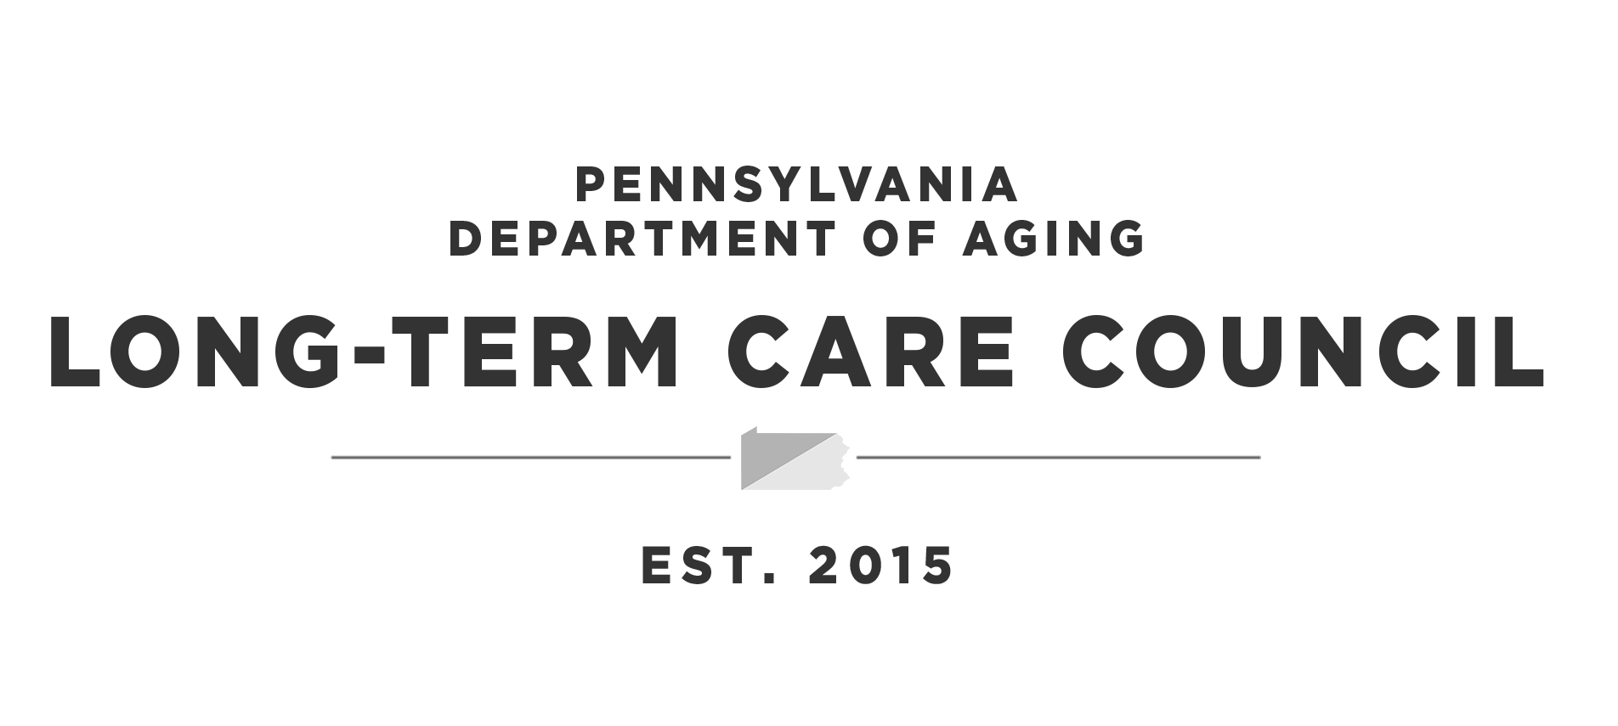

Meeting: | Pennsylvania Long-Term Care Council
Date: | Thursday, December 9, 2021
Start & End Time: | 10:00 a.m. to 11:30 a.m.
Location/Format: | WebEx/Conference Line Connection Information  - Click here to join meeting via your computer.  - Meeting number: 2537 784 9497  - Password: LTCC  Use the following information to join by phone only  - Meeting Phone #: 1-844-621-3956  - Meeting number (access code): 173.243.2.68  In-Person  - PA Department of Aging, 555 Walnut Street, 5th Floor Harrisburg, PA 17101

Agenda
# | Item | Additional Information
1 | Welcome  &  Council Updates | Secretary Robert Torres, Council Chair  Glenda Ebersole, Executive Director
2 | Approval of October 14, 2021 Meeting Minutes
3 | Commonwealth Updates | Secretary Torres  Jennifer Hale  Dir. of the Bureau of Policy and Regulatory Management  Office of Long-Term Living  PA Department of Human Services
4 | COVID-19 Nursing Workforce Initiative – Nursing Loan Foregiveness Program | Elizabeth K. McCloud, Vice President, PA State Grant and Special Programs, PHEAA
5 | Healthcare Group Sponsor Apprenticeship Industry Partnership | James Martini, Executive Director, PA Workforce Development Board
6 | Nurse Aide Update | Eric Levis, Deputy Policy Director  Pennsylvania Department of Education
7 | Direct Care Worker Recruitment Communications Update | Karen Gray, Communications Director, PA Department of Aging
8 | 2022 Meeting Dates | Thursday, February 10  Thursday, April 14  Thursday, June 9  Thursday, August 11  Thursday, October 13  Thursday, December 8
9 | Open Session
10 | Adjournment
Next Meeting: Thursday, February 10, 2022 via WebEx and In-Person

