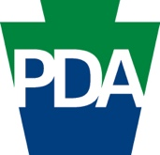Master Plan for Older Adults
Listening Session Social Graphics and Suggested Copy

  - Please Note: The white space on each graphic is intentional so each listening session location can add their details to the graphic before posting.

General Announcement: 1200 x 1200 and 1200 x 650

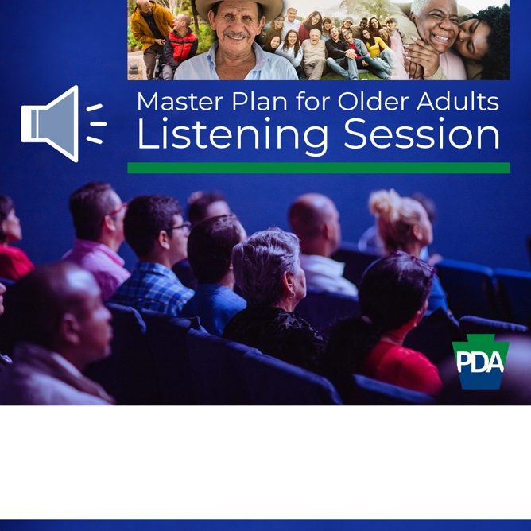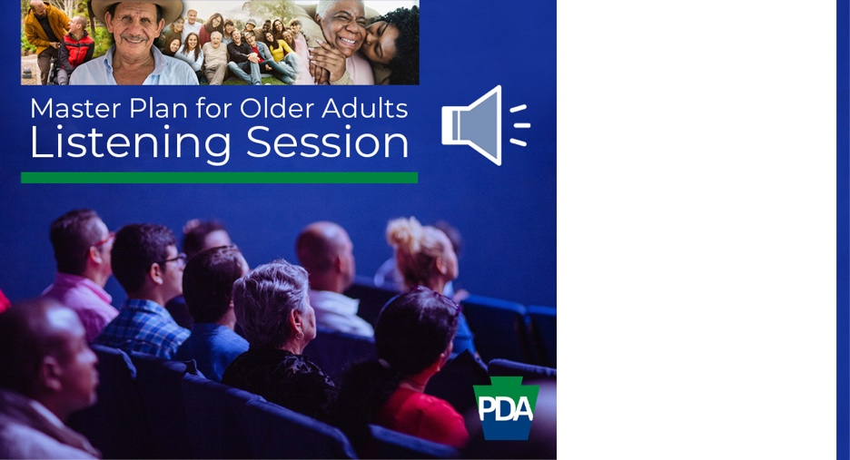

The (tag) Pennsylvania Department of Aging has embarked on the development of a 10-year Master Plan for Older Adults and they want our input!

You’re invited to join us as we host Special Assistant to the Secretary, Kevin Hancock, at (Location) on (Date) at (Time) for a Master Plan Listening Session.

1 Week Away: 1200 x 1200 and 1200 x 650

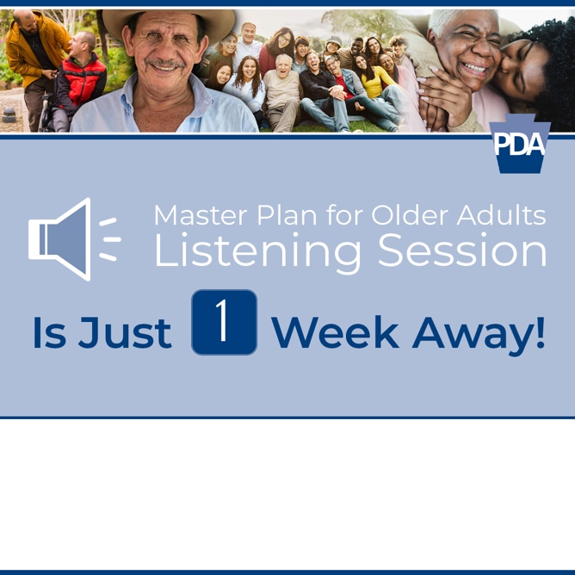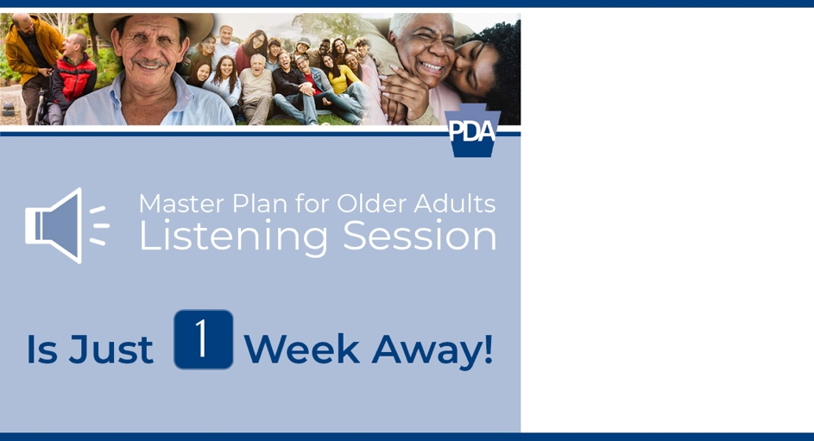

We’re just 1 week away from hosting (tag) Pennsylvania Department of Aging Special Assistant to the Secretary, Kevin Hancock for a Master Plan Listening Session.

You’re invited to join us as we learn about the Master Plan and how we can contribute our input and really have our voice heard. (Location) (Date) (Time).

See you then!

Your Input is Important: 1200 x 1200 and 1200 x 650

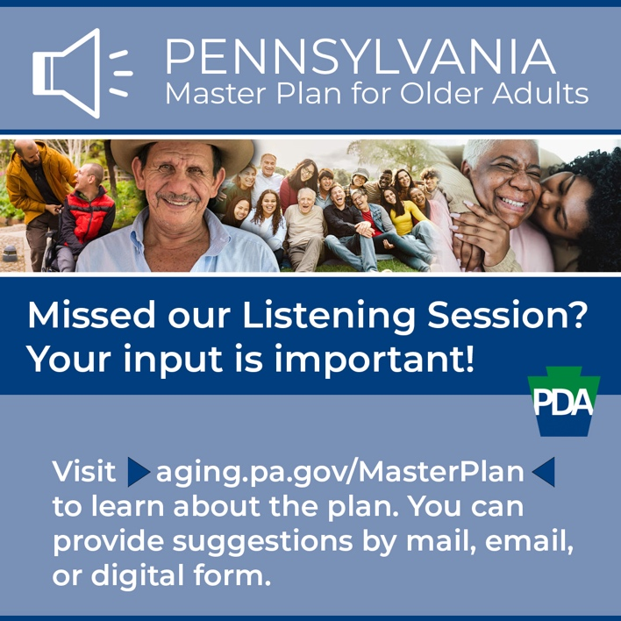

You may have missed our Listening Session, but we still want to hear from you!

We invite you to visit aging.pa.gov/MasterPlan to learn about the plan and to contribute your thoughts on the plan's priority goals, objectives, and initiatives to support the highest quality of life for older adults.
You can submit your input by:
📩 Mail: Pennsylvania Department of Aging, c/o Master Plan, 555 Walnut Street, 5th Floor, Harrisburg, PA 17101
📧 Email: AgingPlan@pa.gov
💻 Digital Form: https://forms.office.com/g/tFt46kYdD5

